Personal Notes

**Date:** July 26, 2019 **Time:** 0930 **Location:** TBD

Attendees: Mr. Fontaine, Simona Babiceanu, Joseph Keogh

* **Plan (Where are we in the process)**

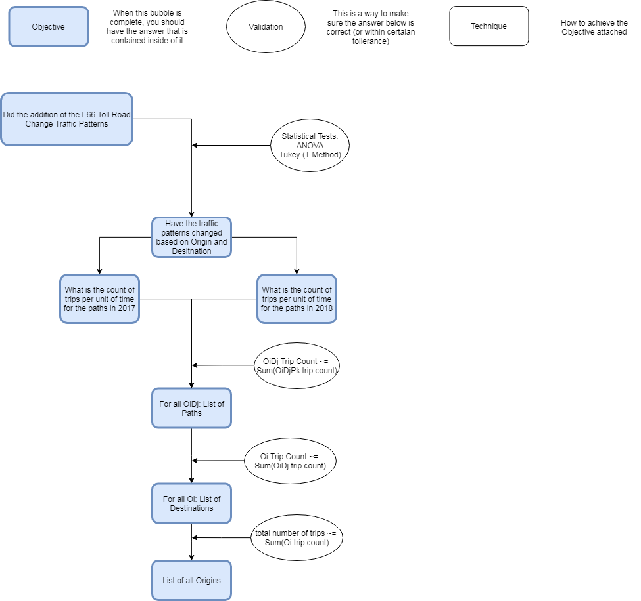



* Deliverables From Last Time
  + Send Parkway info to Simona
  + Rerun program on Rivanna with new Trip to Path matching
  + Redo risk analysis with new Rivanna output
  + New OD Map show new OD Map, one for DC and one for NOVA in tableau
  + Tableau for inbound and outbound Show Tableau tables (use big screen and print outs)
* Other Tasks Completed
  + Paper started
    - Print out
  + Statistical Analysis started
    - Flow is done, just need numbers
      * Done ish
  + Have program flow
    - Draw.io visual
  + OD Counts visualized
    - Graph in excel (using tableau input file)
* Findings
  + Pair T test
    - All combinations (same OD node, same DoW, same Time, same Path
      * Definitely not the same traffic patterns
      * Makes sense
        + Path matches are so slim
* Questions
  + Bringing this up again
    - Multiple paths mapped to same trip id
  + Stat
    - Using “comparing two large sample proportions”
      * What are we considering to be the entire sample
        + Options

OD Node count

Time node count

What interval

DoW and half hour

DoW and full hour

Etc

DoW and Period

What is AM what is PM

* + - * What are considering to be a success
        + Path ID
      * Going to have thousands of results (not for entire sample but for individual paths)
    - Using Pair T test
      * Buckets for different proportions
        + What are the buckets (same question as above)
      * This is for comparing means, not really proportions
* Next Steps
  + Rerun program on Rivanna with new Trip to Path matching
  + Redo risk analysis with new Rivanna output
  + Stat analysis on new Rivanna output
  + For paper
    - Lesser rough draft
    - Start visuals
    - Literature review

Notes